A Major Project Report on
Object Detection using YOLO
Submitted in Partial fulfillment of requirements for the award of the degree of

BACHELOR OF TECHNOLOGY

In INFORMATION TECHNOLOGY
By

JAGAN KOMMA 21BD1A1273
KOLICHELIME GOUTHAM RAJ 21BD1A1297
GAURAV CHELLA 21BD1A1277

Under the guidance of

Ms. Nidhi Srivastav
Assistant Professor, Department of IT



DEPARTMENT OF INFORMATION TECHNOLOGY

KESHAV MEMORIAL INSTITUTION OF TECHNOLOGY
(AN AUTONOMOUS INSTITUTE)
Accredited by NBA & NAAC, Approved by AICTE, Affiliated to JNTUH.
Narayanaguda, Hyderabad, Telangana-29
2024-25



KESHAV MEMORIAL INSTITUTION OF TECHNOLOGY
(AN AUTONOMOUS INSTITUTE)
Accredited by NBA & NAAC, Approved by AICTE, Affiliated to JNTUH.
Narayanaguda, Hyderabad, Telangana-29
2024-25

DEPARTMENT OF INFORMATION TECHNOLOGY

CERTIFICATE


This is to certify that this is a bonafide record of the project report titled “Object Detection using YOLO” which is being presented as the Major Project report by

- JAGAN KOMMA 21BD1A1273
- KOLICHELIME GOUTHAM RAJ 21BD1A1297
- GAURAV CHELLA 21BD1A1277

In partial fulfillment for the award of the degree of Bachelor of Technology in Information Technology affiliated to the Jawaharlal Nehru Technological University Hyderabad, Hyderabad

Internal Guide Head of Department
(Ms.Nidhi Srivastav) (Dr. G. Narender)

Submitted for Viva Voce Examination held on

Vision & Mission of KMIT

Vision of KMIT

- To be the fountainhead in producing highly skilled, globally competent engineers.
- Producing quality graduates trained in the latest software technologies and related tools and striving to make India a world leader in software products and services.

Mission of KMIT
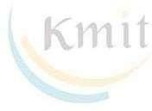
- To provide a learning environment that inculcates problem solving skills, professional, ethical responsibilities, lifelong learning through multi modal platforms and prepares students to become successful professionals.
- To establish an industry institute Interaction to make students ready for the industry.
- To provide exposure to students on the latest hardware and software tools.
- To promote research-based projects/activities in the emerging areas of technology convergence.
- To encourage and enable students to not merely seek jobs from the industry but also to create new enterprises.
- To induce a spirit of nationalism which will enable the student to develop, understand India's challenges and to encourage them to develop effective solutions.
- To support the faculty to accelerate their learning curve to deliver excellent service to students.

Vision & Mission of IT

Vision of the IT
To produce globally competent graduates to meet the modern challenges through contemporary knowledge and moral values committed to build a vibrant nation

Mission of the IT

- To create an academic environment, which promotes the intellectual and professional development of students and faculty.

- To impart skills beyond university prescribed to transform students into a well-rounded IT professional.
- To nurture the students to be dynamic, industry ready and to have multidisciplinary skills including e-learning, blended learning and remote testing as an individual and as a team.
- To continuously engage in research and projects development, strategic use of emerging technologies to attain self-sustainability.

PROGRAM OUTCOMES (POs)

PO1. Engineering Knowledge: Apply the knowledge of mathematics, science, engineering fundamentals, and an engineering specialization to the solution of complex engineering problems.

PO2. Problem Analysis: Identify formulate, review research literature, and analyze complex engineering problems reaching substantiated conclusions using first principles of mathematics, natural sciences, and engineering sciences


PO3. Design/Development of solutions: Design solutions for complex engineering problems and design system components or processes that meet the specified needs with appropriate consideration for the public health and safety, and the cultural, societal, and environmental considerations.

PO4. Conduct Investigations of Complex problems: Use research-based knowledge and research methods including design of experiments, analysis and interpretation of data, and synthesis of the information to provide valid conclusions.

PO5. Modern Tool Usage: Create select, and, apply appropriate techniques, resources, and modern engineering and IT tools including prediction and modeling to complex engineering activities with an understanding of the limitations.

PO6. The Engineer and Society: Apply reasoning informed by contextual knowledge to societal, health, safety. Legal und cultural issues and the consequent responsibilities relevant to professional engineering practice.

PO7. Environment and Sustainability: Understand the impact of the professional engineering solutions in societal and environmental contexts and demonstrate the knowledge of, and need for sustainable development.

PO8. Ethics: Apply ethical principles and commit to professional ethics and responsibilities and norms of the engineering practice.

PO9. Individual and Team Work: Function effectively as an individual, and as a member or leader in diverse teams and in multidisciplinary settings.
PO10. Communication: Communicate effectively on complex engineering activities with the engineering community and with society at large, such as, being able to comprehend and write effective reports and design documentation, make effective presentations, and give and receive clear instructions.

PO11. Project Management and Finance: Demonstrate knowledge and understanding of the engineering and management principles and apply these to one's own work, as a member and leader in a team, to manage projects and in multidisciplinary environments.


PO12. Life-Long Learning: Recognize the need for, and have the preparation and ability to engage in independent and life-long learning in the broadest context of technological change.

PROGRAM SPECIFIC OUTCOMES (PSOs)

PSO1: An ability to analyze the common business functions to design and develop appropriate Information Technology solutions for social upliftments.

PSO2: Shall have expertise on the evolving technologies like Python, Machine Learning, Deep learning, IOT, Data Science, Full stack development, Social Networks, Cyber Security, Mobile Apps, CRM, ERP, Big Data, etc.

PROGRAM EDUCATIONAL OBJECTIVES (PEOs)

PEO1: Graduates will have successful careers in computer related engineering fields or will be able to successfully pursue advanced higher education degrees.
PEO2: Graduates will try and provide solutions to challenging problems in their profession by applying computer engineering principles.
PEO3: Graduates will engage in life-long learning and professional development by rapidly adapting to the changing work environment.
PEO4: Graduates will communicate effectively, work collaboratively and exhibit high levels of professionalism and ethical responsibility.
PROJECT OUTCOMES

P1: Achieve real-time object detection with high accuracy on images, videos, or live camera feeds.
P2: Traffic monitoring (detecting vehicles, pedestrians, traffic signs)
P3: Train YOLO on custom objects and demonstrate accurate detection and classification.
P4: Display bounding boxes around detected objects with labels and confidence scores.

MAPPING PROJECT OUTCOMES WITH PROGRAM OUTCOMES

PO | PO1 | PO2 | PO3 | PO4 | PO5 | PO6 | PO7 | PO8 | PO9 | PO10 | PO11 | PO12
P1 | H | M | H | M | H | L | H
P2 | M | H | H | M | H | L | M
P3 | M | M | H | H | H | L | H
P4 | H | M | H | H | H | L | L

L – LOW M –MEDIUM H– HIGH
PROJECT OUTCOMES MAPPING WITH PROGRAM SPECIFIC OUTCOMES

PSO | PSO1 | PSO2
P1 | H | H
P2 | H | H
P3 | M | H
P4 | M | M

PROJECT OUTCOMES MAPPING WITH PROGRAM EDUCATIONAL OBJECTIVES

PEO | PEO1 | PEO2 | PEO3 | PEO4
P1 | H | M | H
P2 | M | H | M
P3 | H | M | M | H
P4 | M | H | H | M

DECLARATION


We hereby declare that the results embodied in the dissertation entitled “Object Detection using YOLO'' has been carried out by us together during the academic year 2024-25 as a partial fulfillment of the award of the B.Tech degree in Information Technology from JNTUH. We have not submitted this report to any other university or organization for the award of any other degree.

STUDENT NAME ROLL NO

JAGAN KOMMA 21BD1A1273
KOLICHELIME GOUTHAM RAJ 21BD1A1297
GAURAV CHELLA 21BD1A1277

ACKNOWLEDGEMENT

We take this opportunity to thank all the people who have rendered their full support to our project work. We render our thanks to Dr. B L Malleswari, Principal who encouraged us to do the Project.


We are grateful to Mr. Neil Gogte, Founder & Director, Mr. S. Nitin, Director for facilitating all the amenities required for carrying out this project.

We express our sincere gratitude to Ms. Deepa Ganu, Director Academic for providing an excellent environment in the college.

We are also thankful to Dr. G. Narender, Head of the Department for providing us with time to make this project a success within the given schedule.

We are also thankful to our Faculty Supervisor Ms.Nidhi Srivastav, for her valuable guidance and encouragement given to us throughout the project work.

We would like to thank the entire IT Department faculty, who helped us directly and indirectly in the completion of the project.

We sincerely thank our friends and family for their constant motivation during the project work.

ABSTRACT

Object detection is a pivotal technology in computer vision, with applications spanning various fields such as surveillance, healthcare, robotics, and autonomous systems. This project leverages YOLO (You Only Look Once), a state-of-the-art, real-time object detection algorithm, known for its high accuracy and efficiency. The primary goal of this project is to develop a robust system capable of detecting and classifying objects in images and videos, offering a seamless balance between speed and precision. By employing YOLO's single neural network framework, the system processes entire images in one forward pass, enabling real-time object detection on resource-constrained devices.
To cater to specific applications, the project involves training YOLO on a custom dataset. This includes annotating images for object classes, fine-tuning hyperparameters, and optimizing the model for specific requirements like detecting small objects or handling low-light conditions. The system's performance is evaluated using metrics such as precision, recall, and mean Average Precision (mAP), ensuring accuracy and reliability in practical scenarios. Additionally, the model is integrated with a user-friendly interface for ease of use, allowing users to analyze images or live camera feeds efficiently.
This project demonstrates the versatility of YOLO by deploying the model in real-time applications, including live surveillance, traffic monitoring, and object counting. The outcomes highlight YOLO's potential to revolutionize object detection systems across diverse domains. The success of this project lays a foundation for further advancements, such as integrating the model with multi-object tracking, edge devices, or cloud platforms, making it scalable and adaptable to emerging challenges in computer vision.
The project emphasizes the practical deployment of YOLO by implementing real-time object detection on live video feeds and pre-recorded datasets. A simple yet functional interface has been designed to allow users to visualize detection results seamlessly, highlighting detected objects with bounding boxes and labels. The project also explores optimization techniques to enhance YOLO's performance, such as reducing inference time on resource-limited devices and fine-tuning the model for specific use cases. These enhancements ensure the system is not only accurate but also efficient and scalable for real-world applications, paving the way for its integration into various industries.
It trains the model on a custom dataset to detect and classify objects in real-time from images and videos. With a user-friendly interface and optimized performance, the system demonstrates practical applications in areas like surveillance, traffic monitoring, and object counting, showcasing YOLO's versatility and efficiency.

LIST OF FIGURES

S. No | Name of Diagram | Page No.
1. | Architecture Diagram | 14
2. | Use Case Diagram | 18
3. | Sequence Diagram | 20
4. | State Chart Diagram | 23
5. | Class Diagram | 26

CONTENTS

DESCRIPTION PAGE
CHAPTER - 1 1
- INTRODUCTION 2-4
  - Purpose of the project 2
  - Problem with Existing Systems 2
  - Proposed System 3
  - Scope of the Project 4
CHAPTER – 2 5
- LITERATURE SURVEY 6-7
CHAPTER - 3 8
- SOFTWARE REQUIREMENT SPECIFICATION 9-14
  - Introduction to SRS 9
  - Role of SRS 9
  - Requirements Specification Document 10
  - Functional Requirements 11
  - Non-Functional Requirements 12
  - Performance Requirements 12
  - Software Requirements 13
CHAPTER – 4 15
- SYSTEM DESIGN 16-33
  - Introduction to UML 16
  - UML Diagrams 17
    - Use Case Diagram 17
    - Sequence Diagram 18
    - State Chart Diagram 21
    - Class Diagram 24
  - TECHNOLOGIES USED 27

CHAPTER-1

INTRODUCTION

Purpose of the project

Object Detection using YOLO, is to develop an efficient and accurate system for detecting and classifying objects in images and videos. By leveraging YOLO (You Only Look Once), the project aims to provide real-time object detection capabilities with high accuracy, enabling applications in various domains such as surveillance, security, traffic monitoring, and automated systems.
The goal is to create a reliable model that can process images or video streams quickly and accurately, identifying objects within a single pass of the neural network. Through this project, you seek to optimize YOLO's performance, potentially customizing it for specific object classes or improving detection in challenging environments, such as low light or dense scenes. Ultimately, the purpose of the project is to push the boundaries of real-time computer vision, making object detection faster and more accessible for real-world applications.

Problem with Existing Systems

Existing object detection systems, including older versions of YOLO and other models like SSD and Faster R-CNN, face several challenges that can limit their effectiveness in real-world applications. One major issue is the trade-off between accuracy and speed. While YOLO is known for its speed, it sometimes sacrifices precision, especially when detecting small or occluded objects. On the other hand, more accurate models can be slower, making them less suitable for real-time tasks such as surveillance or autonomous driving.

Another challenge is the difficulty in detecting small objects or those located far away in an image. Due to the grid-based nature of YOLO, small objects may not be captured accurately, resulting in poor performance in applications like aerial surveillance or retail monitoring. Additionally, many existing systems struggle with generalizing across diverse environments and lighting conditions. For instance, models trained on high-quality images may fail in low-light scenarios or when objects are partially obstructed, which is a significant limitation for use in nighttime surveillance or autonomous vehicles.

Object detection models often face difficulties when applied to custom or unseen objects. Fine-tuning these models for specialized applications can be time-consuming and requires substantial amounts of labeled data. Furthermore, these systems can demand significant computational resources, especially during training, making them unsuitable for deployment on edge devices or mobile platforms. Poor performance on overlapping objects is another limitation, as densely packed or stacked objects are often misclassified or not detected correctly. Additionally, the complexity of fine-tuning these models to achieve optimal results can be a barrier for users without deep technical expertise. Finally, many pre-trained models are not robust enough to handle real-world scenarios, as they may not generalize well to new, dynamic, or cluttered environments.

In addition to the challenges mentioned above, another significant problem with existing object detection systems is their limited ability to adapt to real-time requirements in dynamic environments. Many systems struggle to maintain consistent performance when there are rapid changes in scenes, such as moving vehicles, shifting crowds, or fluctuating lighting conditions. This can be a critical issue in applications like traffic monitoring, surveillance, and robotics, where the environment is constantly changing, and fast, reliable detection is required.
Moreover, while YOLO is efficient for real-time processing, it can still face difficulties when it comes to accuracy in detecting complex objects, such as those with irregular shapes or multiple instances in a single frame. This can lead to false positives, missed detections, or inaccurate object classification. In scenarios where precision is critical, such as medical imaging or industrial inspections, these issues can significantly impact the system's overall effectiveness.
Another issue is the lack of integration with other advanced technologies, such as 3D object detection, depth sensing, or multi-modal systems. Most traditional object detection models, including YOLO, are limited to 2D image-based analysis and do not leverage additional sensor data or multi-camera setups, which could significantly improve detection accuracy and depth perception in complex environments. This lack of multi-sensory integration limits the versatility of current object detection systems.
The training process itself can also be a bottleneck in existing systems, as the need for large annotated datasets and extensive computational resources can make it difficult to scale these models to new use cases. The reliance on large datasets for training limits the ability of models to be customized for niche or specialized applications, such as detecting rare or unique objects that do not appear in popular datasets. Additionally, existing systems may struggle to effectively handle noisy or incomplete data, further reducing their reliability in real-world scenarios.

Proposed System
The proposed system aims to address the limitations of existing object detection models by leveraging the latest advancements in YOLO for improved accuracy, speed, and adaptability in real-world applications. The core focus of the system is to enhance the detection capabilities, particularly for small, occluded, and overlapping objects, while maintaining real-time processing speeds. By fine-tuning YOLO for specific use cases, the system will offer improved detection performance, especially in challenging environments such as low-light conditions, dense scenes, and complex object arrangements.
The system will incorporate multi-level optimizations to handle diverse detection scenarios. These include implementing techniques like data augmentation to increase model robustness, and custom anchor box tuning for better handling of various object sizes. The model will also undergo training on diverse datasets to ensure better generalization across different domains, allowing it to detect a wide range of objects with high precision.
To ensure scalability and adaptability, the system will be built on a lightweight, modular architecture that can be easily deployed on both high-performance systems and edge devices with limited computational power. This will be achieved by incorporating model compression techniques such as pruning and quantization, allowing the system to maintain performance even on resource-constrained platforms like mobile devices, drones, or IoT devices.
The proposed system will also integrate advanced features such as multi-object tracking and the ability to handle real-time video feeds, enabling applications in surveillance, autonomous vehicles, industrial automation, and smart cities. Additionally, it will support seamless integration with other sensor modalities, such as depth sensing or multi-camera setups, for enhanced object detection accuracy in 3D environments. By focusing on real-time performance, flexibility, and accuracy, the system aims to provide a robust and scalable object detection solution that addresses the shortcomings of current models and is adaptable to a wide range of use cases.

Scope of the Project
The scope of the Object Detection using YOLO project encompasses the development, optimization, and deployment of a real-time object detection system using the YOLO (You Only Look Once) architecture. The project aims to focus on both technical and practical aspects, ensuring the model can be effectively used in real-world applications while addressing the limitations of current systems.
The project will begin with the implementation and fine-tuning of YOLO for detecting a variety of objects, with a particular focus on improving performance for small and occluded objects, which are often challenging for existing models. The system will be trained on multiple datasets to enhance its robustness and generalization capabilities, ensuring it can detect a wide range of object classes with high precision and accuracy.
The scope includes the optimization of the YOLO model for real-time detection on a variety of hardware platforms, from high-performance systems to mobile devices and edge computing environments. This will involve techniques such as model pruning, quantization, and multi-level optimization to ensure efficient deployment even on resource-constrained devices, such as smartphones, drones, or embedded systems.
Furthermore, the project will integrate additional features such as multi-object tracking and support for video feeds, which will enable use cases in surveillance, autonomous vehicles, robotics, and industrial automation. The system will be designed to handle dynamic, real-time environments, addressing challenges like varying lighting conditions, rapid scene changes, and complex object arrangements.
Additionally, the project will explore the possibility of combining YOLO with other sensor technologies, such as depth sensing or multi-camera setups, to improve detection accuracy and provide richer, more detailed object recognition in 3D space. This will expand the scope to include applications in fields such as augmented reality, smart cities, and advanced robotics.
The project will also focus on providing an easy-to-use interface, making the system accessible to both technical and non-technical users. Ultimately, the goal is to create a scalable, flexible, and efficient object detection system that can be adapted to a wide range of industries and applications, providing real-time insights and enabling more accurate decision-making in diverse environments.
A key aspect of the project is the development of a solution capable of adapting to various environmental conditions. The system will be optimized for different lighting environments, varying object sizes, and challenging scenarios such as partial occlusion, low resolution, or cluttered scenes. This means that the project will incorporate data augmentation techniques and domain-specific training to enhance the model's ability to detect objects in diverse contexts, making it suitable for industries such as healthcare, where detection of medical conditions or tools can be critical, or manufacturing environments, where the system needs to identify defects in production lines.

CHAPTER-2

LITERATURE SURVEY

Object detection has evolved significantly over the years, with early systems relying on traditional machine learning algorithms like Haar cascades, support vector machines (SVM), and decision trees. These methods, often combined with hand-crafted features such as HOG (Histogram of Oriented Gradients) or SIFT (Scale-Invariant Feature Transform), were limited in their accuracy, scalability, and ability to handle complex environments, occlusions, and small objects. As object detection technology progressed, deep learning-based methods, particularly convolutional neural networks (CNNs), began to dominate the field. Models like R-CNN (Regions with CNN features) introduced a new paradigm by combining region proposals with CNNs for object localization. However, R-CNN and its variants (Fast R-CNN, Faster R-CNN) had significant drawbacks, primarily in terms of computational cost and the time required for both training and inference.
YOLO (You Only Look Once) revolutionized the object detection field by offering real-time detection with high accuracy. Unlike region-based models, YOLO treats object detection as a regression problem, where it predicts both bounding boxes and class probabilities directly from an image in a single pass. This innovation dramatically improved speed, making real-time object detection feasible even on commodity hardware. However, YOLO faced issues with small object detection and localization, particularly due to its coarse grid system that sometimes struggled to capture fine details. YOLOv2 introduced improvements, including better bounding box predictions, multi-scale training, and the ability to detect over 9000 object classes, while YOLOv3 further refined the model with stronger architecture, residual connections, and improved feature extraction. YOLOv4 built on this success with advanced features like CSPDarknet53 for feature extraction and new data augmentation techniques like mosaic and self-adversarial training.
Despite these advancements, several challenges remain. YOLO still struggles with small object detection and performs poorly when objects are overlapping or occluded. While YOLO is fast, it may not always provide the best results in such cases, with models like SSD (Single Shot MultiBox Detector) and Faster R-CNN performing better in handling small and dense objects but sacrificing speed. Moreover, YOLO's deployment on resource-constrained devices, such as mobile phones or drones, requires optimization techniques like model pruning, quantization, and knowledge distillation to maintain real-time performance. Furthermore, YOLO’s grid-based system limits its ability to effectively handle complex environments with high-density objects, making it less suitable for scenarios like crowd detection, traffic monitoring, or certain industrial applications where objects are packed closely together.
While YOLO has seen significant adoption in real-world applications, such as autonomous vehicles, surveillance, retail, and healthcare, further optimization is needed for more specialized use cases. The ability to integrate YOLO with additional sensor modalities, such as LiDAR, depth sensing, or multi-camera setups, can enhance detection accuracy in more complex environments, such as autonomous driving or industrial automation. Additionally, the combination of YOLO with 3D object detection technologies and multi-modal systems is an exciting area of research that could lead to more robust, context-aware detection systems. In the future, integrating transformer-based architectures, like DEtection TRansformers (DETR), may further enhance detection capabilities by improving localization and handling complex object relationships in dense scenes.
This project aims to build upon the foundations of YOLO, addressing some of its challenges by implementing fine-tuning methods to improve performance in small object detection, overlapping object identification, and dynamic real-time environments,By incorporating advanced features such as multi-object tracking and integration with other sensor data, this project will enhance YOLO’s versatility and applicability to real-world scenarios. The system will focus on optimizing the model for resource-constrained devices to ensure wide usability across various industries, such as security, healthcare, and transportation.
The landscape of object detection has been shaped by significant advancements in machine learning and computer vision. Early object detection methods were based on techniques like sliding window approaches and handcrafted features, which were computationally expensive and lacked robustness in dynamic environments. As the field progressed, deep learning models gained traction, with CNNs at the forefront, leading to breakthroughs like R-CNN. R-CNN and its successors (Fast R-CNN, Faster R-CNN) introduced region-based proposals combined with CNNs, offering improved accuracy over traditional methods. However, the trade-off was computational inefficiency, especially during inference, as they involved multiple stages of processing, which slowed down real-time applications.
The introduction of YOLO marked a turning point in the evolution of object detection. Unlike region-based methods, YOLO approached object detection as a regression problem, predicting bounding boxes and class probabilities in a single forward pass. This approach made YOLO significantly faster, enabling real-time detection on a wide range of devices, including those with limited processing power. YOLOv2 and YOLOv3 further refined this approach, incorporating improvements like multi-scale detection, better network architecture, and the ability to detect a broader range of object classes with increased precision. YOLOv3, for example, introduced residual connections and multi-label classification to improve detection across various scales and categories, making it suitable for diverse applications, from autonomous vehicles to video surveillance.
Despite its successes, YOLO still faces several challenges. The most prominent issue is its struggle with small object detection. YOLO’s grid-based system, which divides the image into a fixed number of cells, can miss small objects or those located at the edge of the grid. While YOLOv3 improved this aspect with finer grid divisions, small object detection remains a major limitation, particularly in applications like traffic surveillance or retail inventory management, where objects may occupy only a small portion of the image. Additionally, YOLO’s performance can degrade in complex environments where objects overlap or are partially occluded, leading to missed detections or false positives. The efficiency of YOLO, while beneficial for real-time processing, comes at the cost of lower precision in such challenging scenarios.
Moreover, the deployment of YOLO in real-world applications often requires optimization to handle edge cases. For instance, YOLO’s models can be large and computationally intensive, requiring techniques like model pruning, quantization, and knowledge distillation to reduce their size and improve inference time without sacrificing accuracy. YOLO’s ability to run on edge devices, such as mobile phones, drones, or embedded systems, is one of its greatest strengths. However, this requires careful tuning to ensure that the model can perform efficiently on devices with limited computational power and memory. This is an area where techniques like model compression and hardware acceleration can play a critical role in ensuring that YOLO remains applicable across various platforms, from cloud-based systems to resource-constrained devices.
Another challenge lies in YOLO’s ability to adapt to new or custom object classes. Although YOLO can be trained on different datasets, it may require substantial amounts of labeled data to achieve high accuracy in novel environments. This is especially true for specialized use cases, such as detecting specific objects in medical imaging, industrial inspections, or rare wildlife detection, where labeled data is often scarce. Researchers have worked on fine-tuning YOLO with transfer learning, enabling the model to adapt quickly to new object classes with minimal data, but this remains a challenge that requires ongoing exploration.

CHAPTER-3

- SOFTWARE REQUIREMENT SPECIFICATION

Introduction to SRS
The Software Requirements Specification (SRS) is a comprehensive document that outlines all the functional and non-functional requirements for a software project. It serves as a blueprint, detailing what the software will do and how it is expected to perform. The SRS ensures that all stakeholders, including developers, project managers, and clients, have a clear understanding of the project's scope, features, and constraints. In essence, it helps bridge the gap between the user’s needs and the technical specifications needed to build the software.

In the context of my project on Object Detection using YOLO, the Software Requirements Specification (SRS) serves as a critical document to define the functional and non-functional requirements for the system you're developing. It ensures that the project meets the objectives of accurately detecting and classifying objects in real-time using the YOLO (You Only Look Once) model.

Role of SRS
The SRS plays several vital roles in the development process, helping guide the project from inception to completion. Here are some of its primary functions:

Foundation for Development
The SRS serves as a foundation upon which the entire development process is built. It acts as a clear guideline for developers to understand what is expected, including specific functionality, user interactions, and system behaviors.

Communication Tool
By providing a detailed and structured outline, the SRS acts as a communication bridge between stakeholders, including clients, developers, and project managers. It ensures that all parties have a unified understanding of project requirements, reducing ambiguities and aligning expectations.

Scope Management
The SRS defines the scope of the project, listing the features, capabilities, and constraints. This helps manage the project's scope and prevents scope creep by establishing boundaries for what is to be included and what is out of scope.

Basis for Validation and Testing
An SRS provides a reference for testing and validation by documenting what the software should accomplish. It allows quality assurance teams to create test cases that verify whether the software meets its intended functionality and performance criteria.

Contractual Agreement
The SRS can also serve as a formal contractual document between clients and developers. By clearly specifying requirements, it becomes a basis for measuring progress and evaluating the final product, ensuring the project meets client expectations.

Facilitation of Maintenance and Future Development
A well-documented SRS makes it easier to understand the system’s initial requirements, which can be invaluable for future maintenance and development. It serves as a reference for any necessary updates or enhancements to the system, providing continuity even if there are changes in the development team.
A well-written SRS helps avoid misunderstandings and miscommunications between stakeholders, developers, and testers, ultimately contributing to the success of the software project. It helps in planning the development process, defining milestones, and setting realistic expectations regarding system performance, usability, and compatibility with other systems

Requirements Specification Document
The Requirements Specification Document (RSD) is a detailed description of all the requirements necessary for the development of the Object Detection using YOLO. This document will guide the design, development, testing, and implementation of the project to ensure it meets the needs of both job seekers and employers.

The document is structured as follows:

- Introduction
  - Purpose
This document provides a detailed specification for the Object Detection using YOLO project. The goal is to design and implement an object detection system using the YOLO deep learning model to detect and classify objects in real-time video streams or images. This document defines the system’s functionality, constraints, performance requirements, and interactions with other systems.
  - Scope
The object detection system will utilize the YOLO framework to detect and classify various objects, with a focus on real-time performance. The system will be applicable in environments such as security, autonomous vehicles, and industrial settings. It will handle multiple object types, provide real-time analysis, and offer scalability for larger datasets.
  - Definitions, Acronyms, and Abbreviations SRS: Software Requirements YOLO: You Only Look Once, an object detection model.
CNN: Convolutional Neural Network.
  - Overview
The object detection system will use YOLO to detect objects from images or video streams, classifying them in real-time.

Functional Requirements

3.4.1 Object Detection and Classification
- The system must be capable of detecting objects in real-time with high accuracy.
- The system should classify detected objects into predefined categories (e.g., cars, pedestrians, animals).
- The model must handle various object sizes, including small and large objects.

3.4.2 Real-Time Performance
- The system must process video streams or images at a minimum of 30 FPS to ensure real-time performance.
- The object detection must be performed within a maximum of 100 ms per frame.

3.4.3 User Interface
- The system should display real-time object detection results, including bounding boxes and object labels.
- The interface should allow users to upload images or video streams for analysis.

3.4.4 Input and Output
- The system should accept images and video inputs in standard formats (JPEG, PNG, MP4, etc.).
- The output should include object identification, classification labels, and bounding box coordinates.

3.5 Non-Functional Requirements

3.5.1 Performance
- The system should maintain high accuracy in detecting objects even under challenging conditions, such as occlusion or low lighting.
- The detection accuracy should be at least 85% for common objects.

3.5.2 Scalability
- The system should be able to handle different types of hardware, from high-performance servers to edge devices.
- It should be scalable to detect a growing set of object classes as new categories are added.

3.5.3 Security
- If the system processes sensitive data (e.g., video streams), the data should be encrypted during transmission and storage.
- The system should have access control mechanisms for limiting who can access and modify the detection system.

3.5.4 Compatibility
- The system should be compatible with commonly used operating systems (Windows, Linux, macOS).
- The system should support integration with existing APIs for third-party applications (e.g., surveillance systems).

3.5.5 Reliability and Availability
- The system should be robust to crashes and able to resume without loss of data.
- It should operate continuously in a production environment, with 99% availability.

3.6 Performance Requirements

3.6.1 Real-Time Detection
- The system must process images or video frames in real-time to support applications such as surveillance or autonomous driving.
- The detection system should achieve a frame rate of at least 30 frames per second (FPS) for video streams, ensuring smooth real-time performance.
- The system should process each frame within 100 milliseconds or less to maintain minimal latency, especially in critical applications like security or traffic monitoring.

3.6.2. Detection Accuracy
- The object detection system should be capable of identifying and classifying objects in images or video streams with a minimum mean average precision (mAP) of 85%.
- The accuracy should be high across various object types, including small, medium, and large objects. Specific accuracy for small object detection should be 70% or higher, addressing the challenge of detecting objects that occupy small areas in the frame.
- The system should be capable of correctly identifying multiple classes of objects (e.g., pedestrians, cars, animals, etc.) with over 80% accuracy in a diverse set of environments.

3.6.3. Detection Speed
- For video streams, the system should maintain real-time object detection, meaning the model should process and classify the frames without significant delays. The latency per frame should be under 100 ms.
- Image processing time (for still images) should be less than 50 ms for smaller-sized images (e.g., 640x480 resolution), ensuring quick feedback in applications like image-based inspections or real-time monitoring.

3.6.4. Resource Efficiency
- The system should be optimized to run efficiently on both high-performance systems (e.g., servers with GPUs) and on resource-constrained devices (e.g., embedded systems, mobile devices, or edge devices).
- On resource-constrained devices, the system should maintain an FPS of 20-30 FPS for real-time detection, balancing accuracy and resource consumption.
- The model should use techniques like model pruning, quantization, and knowledge distillation to ensure reduced model size and faster inference times without significantly sacrificing accuracy

3.7 System Requirements

3.7.1 Hardware Requirements

1.1. Development Environment
- CPU: Intel Core i5 or equivalent (quad-core or higher recommended for faster training and testing).
- GPU: NVIDIA GPU with CUDA support (e.g., NVIDIA GTX 1060 or higher) for faster training and inference.
- RAM: Minimum 8 GB RAM (16 GB recommended for handling larger datasets).
- Storage: At least 100 GB of free disk space (SSD preferred for faster read/write operations).
- Display: A monitor with at least 1080p resolution for optimal code visualization and debugging.

1.2. Deployment Environment
- CPU: Intel Core i3 or equivalent for edge devices or real-time applications.
- GPU: NVIDIA Jetson Nano, NVIDIA Jetson Xavier, or Raspberry Pi with GPU support for mobile and embedded systems.
- RAM: Minimum 4 GB RAM (8 GB recommended for complex tasks).
- Storage: Minimum 32 GB storage for storing the model weights, video/image files, and logs.
- Camera (if applicable): HD camera or IP camera capable of providing video streams at 30 FPS for real-time analysis.
- Power Supply: Adequate power supply for edge devices or embedded systems to ensure continuous operation.

3.7.2 Software Requirements

2.1. Operating System
- Windows (10 or later) or Linux (Ubuntu 18.04 or later recommended).
- For edge deployment, Raspberry Pi OS or Ubuntu for ARM for ARM-based devices.

2.2. Frameworks and Libraries
- Python 3.x: The primary programming language for implementing YOLO and related tasks.
- TensorFlow or PyTorch: Deep learning frameworks for implementing and training YOLO models.
- OpenCV: For image and video processing (e.g., capturing video streams, applying object detection).
- CUDA: If using an NVIDIA GPU for accelerated training and inference.
- NumPy and Pandas: For handling data manipulation and processing.
- Matplotlib/Seaborn: For visualizing detection results during the testing phase.
- Flask or FastAPI: For creating an API for real-time inference (if needed).

2.3. Additional Software Tools
- Jupyter Notebook or PyCharm: For an interactive development environment.
- Git: For version control and collaboration.
- Docker (optional): For creating containerized environments to ensure consistency across development and production environments.
- FFmpeg (optional): For handling video formats and streaming.

3.7.3 Network Requirements
- Internet Connection: Required for downloading pre-trained YOLO models, datasets, and dependencies during the development phase.
- Network Bandwidth: Sufficient bandwidth (at least 1 Mbps) for video streaming or API calls in real-time applications.

3.7.4 Performance Requirements
- Real-Time Processing: The system should be capable of processing at least 30 frames per second (FPS) for real-time video streams or images.
- Detection Accuracy: The system must maintain an average precision of 85% or higher in object detection tasks.
- Low Latency: The system should have minimal inference time (less than 100 milliseconds per frame) to ensure real-time performance

CHAPTER-4

SYSTEM DESIGN

Introduction
The system can be divided into several layers or components that work together to achieve real-time object detection:
- Input Layer:
  - Image/Video Capture: The system accepts input in the form of still images or video streams. These can be uploaded from the user or streamed directly from a camera (e.g., webcam, surveillance camera).
  - Pre-processing: The input images or frames are pre-processed to resize, normalize, and convert them into the format required by the YOLO model.
- Processing Layer:
  - Model Inference: The core component of the system is the YOLO deep learning model. This component is responsible for detecting and classifying objects in the images or video frames.
  - Post-processing: After the YOLO model detects objects, post-processing steps are performed to filter out low-confidence detections and refine the bounding boxes for accuracy.
- Output Layer:
  - Display/Visualization: The results (detected objects, bounding boxes, and class labels) are overlaid onto the original images or video frames and displayed to the user in real-time.
  - Results Storage: Optionally, the system may log or store the detected results, such as object IDs, timestamps, or frame numbers for analysis or record-keeping.
- User Interface (optional):
  - A web-based or mobile interface may be implemented to allow users to upload images or video, start and stop detection, and view results. It can include features for interaction, such as modifying detection settings (e.g., threshold for object confidence).
- Image/Video Input:
- If video input is used, video capture modules (e.g., OpenCV) will handle real-time streaming from cameras or video files.
- If still images are used, the system allows users to upload images in popular formats (JPEG, PNG, etc.).

Use case Diagrams
A use case diagram provides a visual representation of the system's functionality, showing how different users (actors) interact with the system. Below is the description and use case diagram for Object Detection Using YOLO project.

Key Actors
- User:
  - A person or organization using the system to perform object detection.
  - They can upload images/videos, view results, or configure detection parameters.
- System:
  - The object detection system using YOLO, which processes the input and provides output.

Primary Use Cases
- Upload Input:
  - Users upload images or videos for processing by the YOLO-based detection system.
- Start Detection:
  - The system processes the input to detect objects and generates bounding boxes and class labels.
- View Results:
  - Users view the detected objects, their locations (bounding boxes), and classifications on the original input.
- Configure Settings:
  - Users can set parameters like confidence thresholds, detection classes, or resolution preferences.
- Store Results:
  - The system optionally logs the detection data (e.g., object type, bounding box coordinates, and confidence scores) for further use.
- Access Logs:
  - Users retrieve past detection results for review or analysis.

Use Case Diagram Description
The diagram shows:
- The User interacting with the system through primary use cases like uploading input, viewing results, configuring settings, and accessing logs.
- The System as the central component that handles detection, post-processing, and optional result storage.

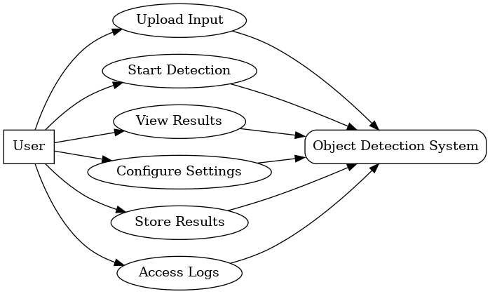

FIG.1

Sequence Diagram
A sequence diagram illustrates the step-by-step interactions between actors and system components over time for a specific use case.The sequence diagram represents the interaction for the primary use case: Object Detection Process.

Key Elements in the Diagram
- Actors:
  - User: Initiates the process by uploading images or videos and viewing the results.
- System Components:
  - Input Module: Handles file uploads or video streams.
  - YOLO Model: Performs object detection by processing the input.
  - Post-Processing Module: Filters and refines the model output.
  - Visualization Module: Displays results with bounding boxes and labels.
  - Database (optional): Stores detection results for future retrieval.

Process Flow
- The User uploads an image or video.
- The Input Module preprocesses the input and passes it to the YOLO Model.
- The YOLO Model detects objects and returns bounding boxes, class labels, and confidence scores.
- The Post-Processing Module refines the results (e.g., applies Non-Maximum Suppression).
- The Visualization Module overlays the bounding boxes and labels on the original input and displays it to the user.
- Optionally, the Database stores the detection results for later use.

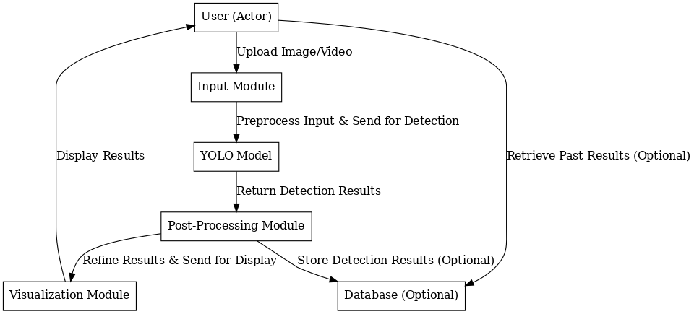

FIG.2

State Chart Diagram
A state chart diagram represents the various states the system goes through during its lifecycle, along with the transitions between those states. For Object Detection Using YOLO project, the states revolve around processing inputs, performing detection, and delivering outputs.

States in the Diagram
- Idle:
  - The system is waiting for user input (e.g., image or video).
- Input Received:
  - The system receives an image or video file and begins preprocessing.
- Preprocessing:
  - The input is resized, normalized, and prepared for the YOLO model.
- Detection in Progress:
  - The YOLO model processes the input and detects objects.
- Post-Processing:
  - The system refines the model's output, filtering low-confidence results and applying Non-Maximum Suppression.
- Displaying Results:
  - The system overlays bounding boxes and class labels on the input and displays the results to the user.
- Results Stored (optional):
  - The detected results are saved in a database for future access.
- Idle:
  - The system returns to the idle state, ready for the next input.

Transitions
- Idle → Input Received: When a user uploads an image or video.
- Input Received → Preprocessing: Once the system validates the input.
- Preprocessing → Detection in Progress: After the input is formatted for the YOLO model.
- Detection in Progress → Post-Processing: After the YOLO model completes inference.
- Post-Processing → Displaying Results: Once the results are refined.
- Displaying Results → Results Stored (optional): If the user opts to save results.
- Displaying Results → Idle: After showing the results, the system resets for the next task.

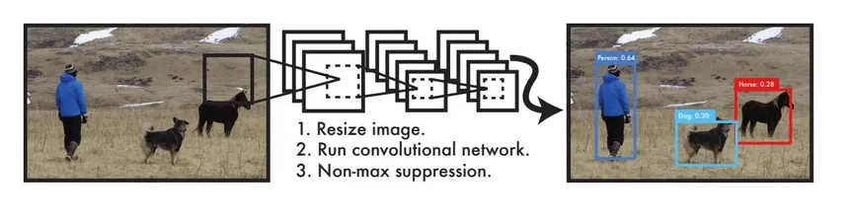

FIG.3

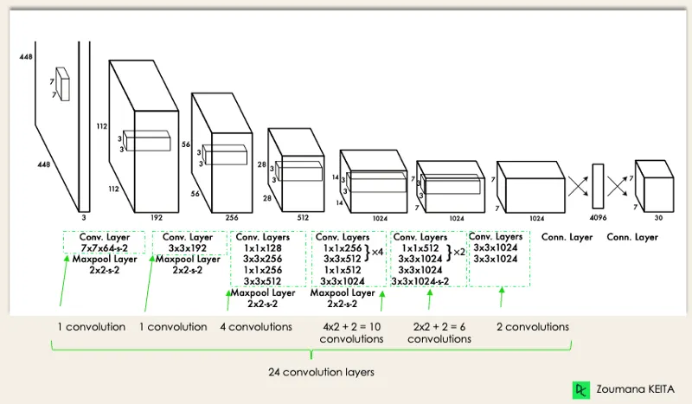
FIG.4

Class Diagram
A class diagram represents the static structure of a system by showing its classes, attributes, methods, and relationships. For Object Detection Using YOLO project, the classes are based on key system components, such as input handling, detection, processing, and visualization.

Key Classes and Relationships
- User:
  - Attributes: userID, name, email
  - Methods: uploadInput(), viewResults()
- InputHandler:
  - Attributes: inputFile, inputType
  - Methods: validateInput(), preprocessInput()
- YOLOModel:
  - Attributes: modelVersion, confidenceThreshold
  - Methods: loadModel(), detectObjects()
- PostProcessor:
  - Attributes: filteredResults
  - Methods: applyNMS(), refineResults()
- Visualizer:
  - Attributes: visualizationStyle
  - Methods: drawBoundingBoxes(), displayResults()
- Database (optional):
  - Attributes: detectionLogs
  - Methods: saveResults(), retrieveResults()

Relationships
- User interacts with InputHandler: Users upload input via the handler.
- InputHandler communicates with YOLOModel: Preprocessed input is sent for detection.
- YOLOModel outputs to PostProcessor: Detection results are refined.
- PostProcessor communicates with Visualizer: Refined results are visualized.
- PostProcessor optionally interacts with Database: Results can be stored or retrieved.

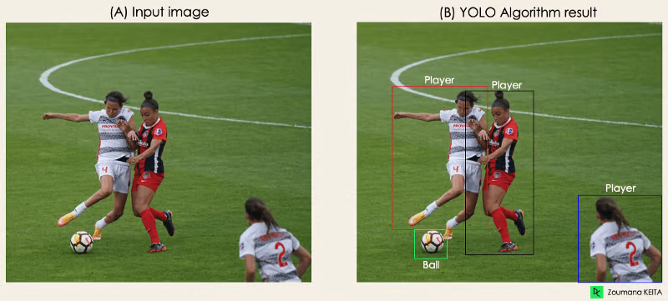

FIG.5

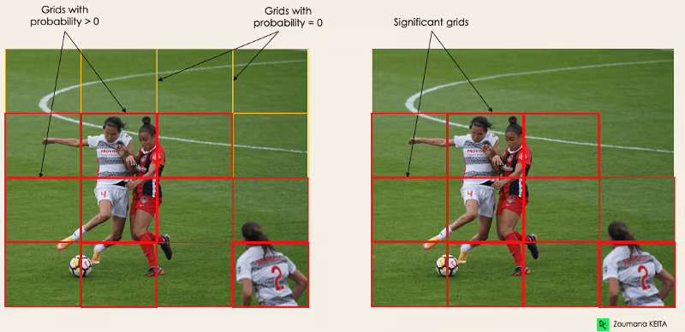

FIG.6

TECHNOLOGIES USED
For Object Detection Using YOLO, the technologies used are tailored to implement and optimize the object detection system. Here's a detailed breakdown:

Programming Languages
- Python:
  - Used for implementing YOLO algorithms, data preprocessing, and integration.
  - Popular libraries: NumPy, OpenCV, TensorFlow, or PyTorch.

Frameworks and Libraries
- YOLO Framework:
  - Implements object detection with pretrained weights and configurations (YOLOv4, YOLOv5, or YOLOv8).
- PyTorch or TensorFlow:
  - Frameworks for loading and fine-tuning the YOLO model.
- OpenCV:
  - For image and video processing, such as resizing, loading input files, and visualizing results.
- NumPy:
  - For handling numerical computations and array manipulations.
- Flask or FastAPI (optional):
  - To build a lightweight API for serving the object detection model.
- Matplotlib/Seaborn:
  - For visualizing results, generating graphs, or metrics.

Development Tools
- Jupyter Notebook:
  - For interactive development and testing of the object detection pipeline.
- VS Code:
  - A powerful IDE for managing the project codebase.

Hardware and Software
- NVIDIA GPU:
  - Essential for training and running YOLO efficiently using CUDA.
- CUDA and cuDNN:
  - NVIDIA libraries for GPU acceleration.
- Operating System:
  - Linux or Windows for development.

Tools, third party plugins and libraries

Development Tools
- IDE/Code Editor:
  - VS Code: For writing and managing code.
  - PyCharm: A Python-specific IDE with debugging and testing tools.
- Jupyter Notebook:
  - For prototyping and testing code in an interactive environment.
- Git:
  - For version control and collaboration.

Third-Party Libraries
- YOLO Framework:
  - Pretrained YOLO models (YOLOv4, YOLOv5, YOLOv8) for object detection.
  - Download from Ultralytics or custom implementations.
- Deep Learning Libraries:
  - PyTorch: For implementing and fine-tuning YOLO.
  - TensorFlow/Keras: Alternative framework for training and deploying YOLO.
- Image Processing:
  - OpenCV: For image and video handling, such as loading inputs, resizing, and visualizing results.
- Numerical Computing:
  - NumPy: For efficient array manipulations and numerical operations.
- Data Visualization:
  - Matplotlib and Seaborn: For plotting metrics, results, and graphs.
  - Plotly (optional): For interactive visualizations.
- API Framework:
  - Flask or FastAPI: For building an API to serve the object detection model.

GPU and Acceleration
- CUDA:
  - Required for running YOLO on NVIDIA GPUs.
- cuDNN:
  - NVIDIA library for deep learning acceleration.

Utilities
- Pretrained Weights:
  - Download YOLO weights (e.g., from YOLO GitHub Repositories or Ultralytics).
- LabelImg:
  - For annotating datasets in case of custom YOLO training.

Database and Storage
- SQLite or MongoDB:
  - For optional storage of detection results or logs.

Plugins
- PyTorch Hub:
  - For easy access to YOLO models and pretrained weights.
- TensorRT:
  - For optimizing YOLO models for faster inference on NVIDIA GPUs.

Additional Libraries
- Pandas:
  - For data analysis and manipulation of detection results.
- Shutil:
  - For file management during input-output operations.
These tools, libraries, and plugins form a cohesive environment for developing a robust and efficient YOLO-based object detection system.

